**Grade:** Kindergarten

**Suggested Supplies:**

* Backpack (large enough to hold your child’s binder, please no wheels)
* Labeled change of clothes in a Ziplock bag (does not need to be a school uniform)
* 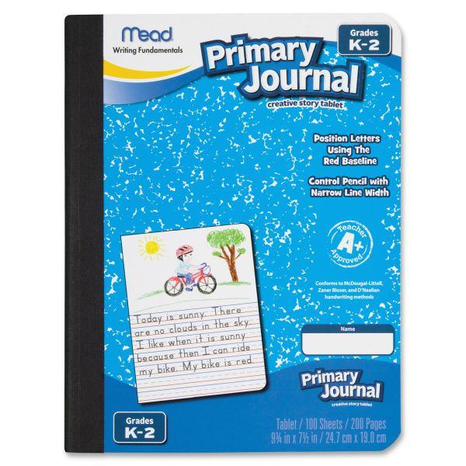**2** Primary Composition Notebooks (K-2) *see insert
* **2** ‘two pocket’ folders with three ring holes
* **½** - inch standard three ring hard plastic binder
* Elmer’s Glue Sticks (Pack of 6)
* **2** - 12 pack (or more) of Crayola Crayons
* **1** pair of safety scissors
* Expo dry erase *FINE* point markers
* 2 - zippered nylon soft pencil case (one for 3 ring binders)
* 1 pack of Dixon Ticonderoga #2 pencils
* 3-pack of Disinfectant Wipes
* 3-pack of Tissues
* 2 rolls of Paper Towels
* 2 packs of flushable baby wipes
* 2 bottles of hand sanitizer (8 oz or bigger is appreciated)
* 2 containers of 4 ounce - Play Doh
* Inexpensive headphones (No bluetooth/wireless or apple iphone adapter)

*\*\*\*\*\*\*\*\*Please label all of your child’s supplies\*\*\*\*\*\*\*\**